**GenSec Industries: Testing Document**

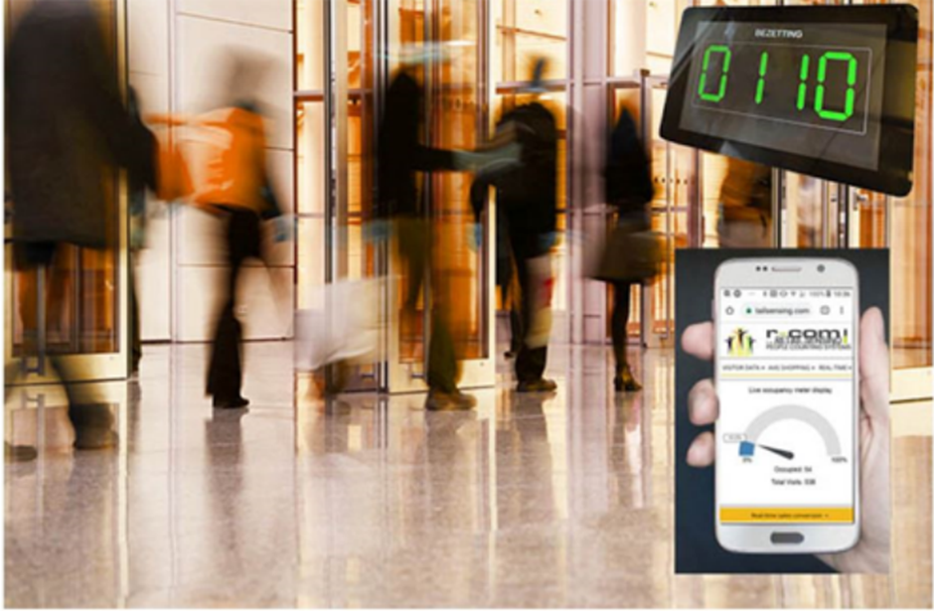  
  
  
  
  
  
  
  
  
  
  
Johnson Domacasse 4471709  
Nedyalko Tenev 4808231  
Tuan Kiet Ho 4832649  
Farros Ramzy 3767353

1. Introduction: 3

2. Test cases: 3

2.1. Functionalities: 3

2.2. Expectations: 4

# Introduction:

*This document focuses on the test cases we have for the occupancy management system. See the following tables for test cases and success/failure margin.*

# Test cases:

*Several types of test cases that will be performed are all categorized under the following names.*

## Functionalities:

|  |  |  |  |
| --- | --- | --- | --- |
| No. | Functionality | Description | Test Step |
| 1. | Calculate person in (Security Check) | Each gate should allow a passenger that was checked-in to go into the security line if the duty-free room is not full. | X` |
| Worst scenario:   * Max occupancy reached. |
| 2. | Calculate person out (Duty-Free room) | Each gate should know how many people are moving out from the duty-free room into their flight before letting another passenger do the security check. | Best scenario:   * Count down on exit. * Count down to zero. |
| Worst scenario:   * Room is empty. |
| 3. | Emergency Trigger | Each gate must be open to let people from inside the security check to get out when an emergency alarm is activated. | Best scenario:   * Emergency is active. * Count down on emergencies. |
| Worst scenario:   * Room already empty. |
| 4. | Gate Direction (Guide) | Each gate must notify the divider in case the queue is busy (for ex.: about more than 25 people in the queue), so the divider can activate another gate for the new passengers. | Best scenario:   * Gate is active and not busy. |
| Worst scenario:   * Gate is active but busy. * Gate is not active. |

*Table 1: Functionality testing.*

## Expectations:

|  |  |  |  |
| --- | --- | --- | --- |
| No. | Test Step | Expected Result | Status |
| 1. | Adding passengers. | Number of entities keep updated as an entry trigger detected until the max is reached. | pass or fail |
| 2. | Update database. | Database can keep track of the on-going data input as a new passenger passed the gate. | pass or fail |
| 3. | Max occupancy reached. | The system blocks all gates while the occupancy is at its max. | pass or fail |
| 4. | Count down on exit. | The number of entities keeps decreasing as an exit trigger is detected. | pass or fail |
| 5. | Count down to zero. | Exit trigger count down only to zero. | pass or fail |
| 6. | Room is empty. (normal) | System not doing count down if the room occupancy is already zero (empty). | pass or fail |
| 7. | Emergency is active. | The system opens all gates and/or emergency doors until the trigger is off. | pass or fail |
| 8. | Countdown to emergency. | The system only counts down during emergencies until the alarm trigger is off. | pass or fail |
| 9. | Room already empty. (emergency) | System locks all entries. (no one and nothing should be able to go into the security line and the duty-free room) | pass or fail |
| 10. | Gate is active and not busy. | A green signal should be displayed on the divider to the corresponding gate. | pass or fail |
| 11. | Gate is active but busy. | A yellow signal should be displayed on the divider to the corresponding gate. And another gate which is not active should be turned active to decrease the busy line traffic. | pass or fail |
| 12. | Gate is not active. | A red signal should be displayed on the divider to the corresponding gate. | pass or fail |